Lab 2: Density

Group Submission
Madelyn Woodrow, Yoaneli Ortiz, Trung Vo, Patrick Ignaut, Marjory Cevallos

PHYS 1401
College Physics -1

3/3/2025

TABLE OF CONTENTS

Objective 3
Equipment 3
Theory and Equations 4
Procedure 5
Data and Observations 5
Calculations 10
Results 13
Sources of Error 13
Discussion 14
Conclusion 14

OBJECTIVE:
In this experiment the dimensions of various objects will be determined by means of a meter ruler, a Vernier caliper, and a micrometer caliper and the probable error in these measurements will be determined. The mass of each object will be measured with a triple beam balance (or electronic balance if available) and the density of each object as well as the material from which it is made will be determined. These measurements will be used with the addition of the overflow can and graduated cylinder to determine the volume of the objects.

EQUIPMENT:
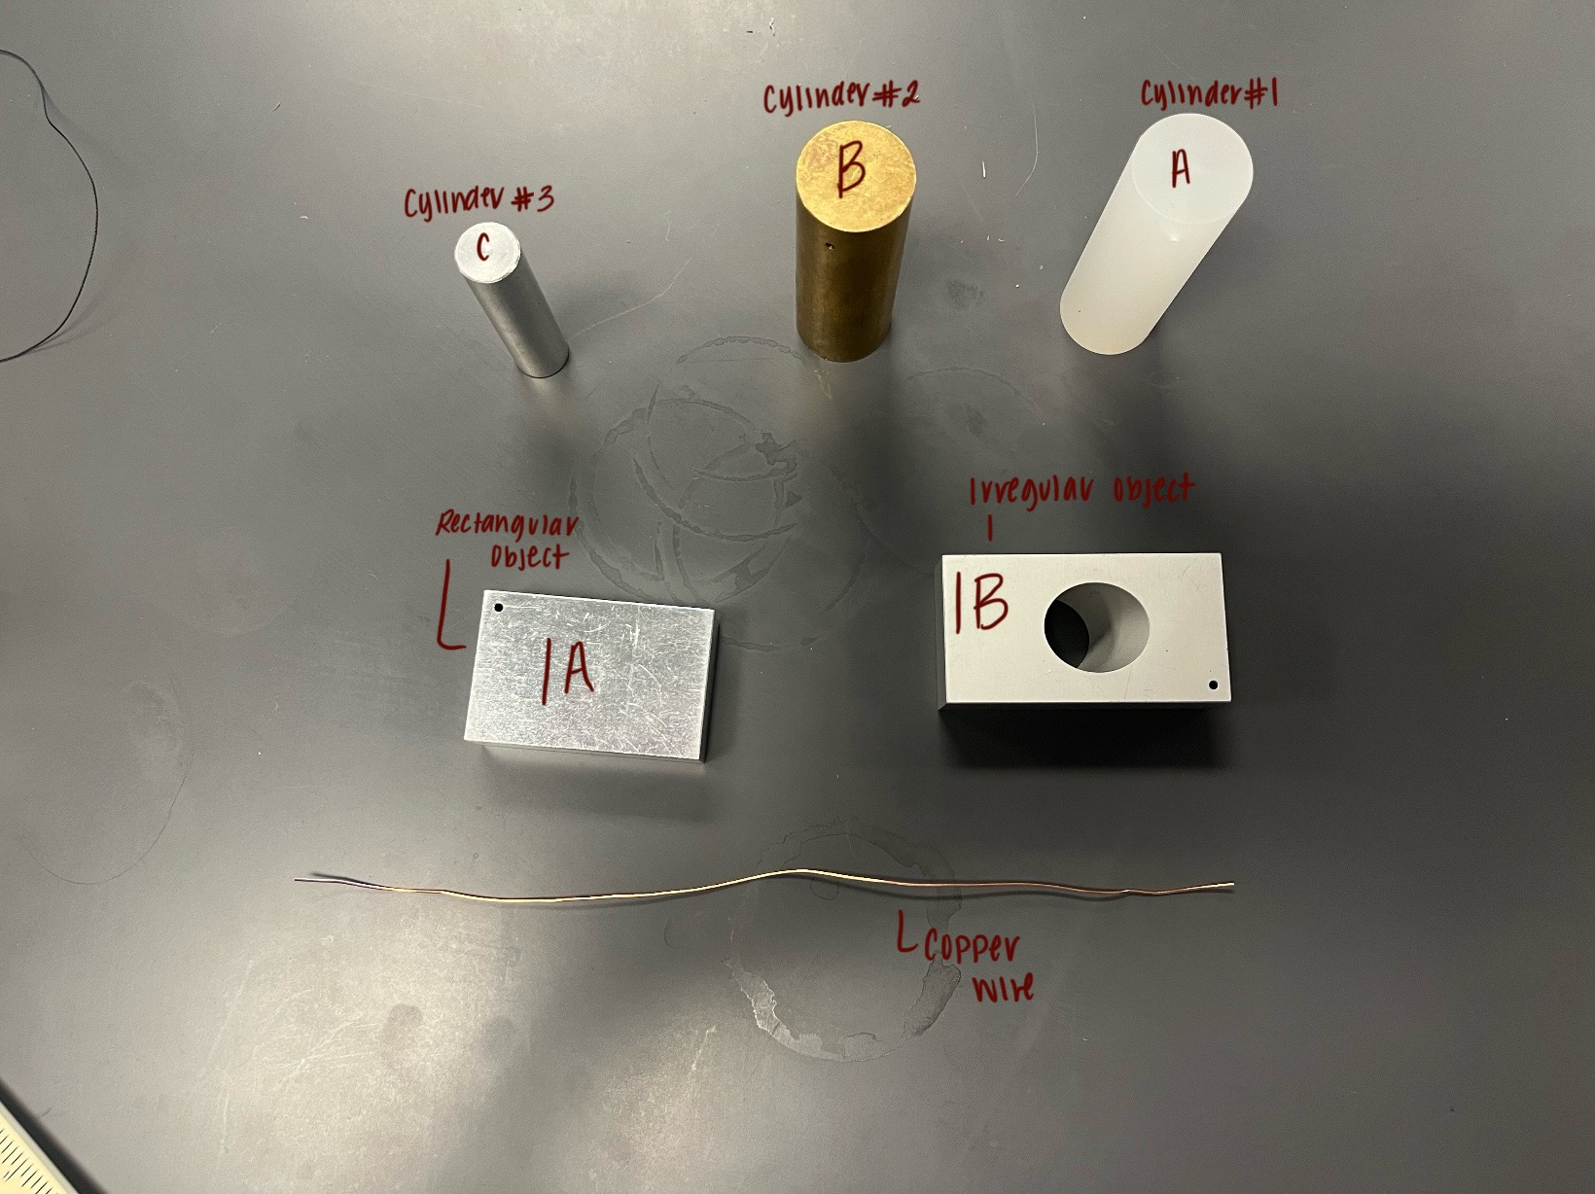
Overflow can | Ruler | Graduated cylinder | Triple beam balance
Micrometer | Vernier caliper | Copper Wire | Irregular object
Rectangular object | Regular cylinders (x3)

THEORY AND EQUATIONS:
Physics is the study of measures, which involves reading many different things. Because of this, it is important to learn how to measure things correctly and figure out what they mean. It's important to note that the measuring tool used determines the number of significant figures that need to be kept in a reading. A meter ruler, a Vernier caliper, and a micrometer caliper will be used to measure the sizes of different items in this experiment. The error that is likely to be made in these measurements will also be found. A triple-beam balance (or an electronic balance if one is available) will be used to measure the mass of each item. The density and material of each object will also be found.
The measure of how dense matter is in a material is its density. Getting the volume and mass of the material could be used to do this in an experiment. Depending on the shape of the thing, there are different ways to find its volume. For example, to find the volume of a solid that has a regular shape, equations are used. However, to find the volume of an item with an odd shape, it can be submerged in water in a graduated cylinder. Something usually moves its own volume of water, so the difference between what the cylinder read before and after the item was submerged shows how much the object is.
Equations:
Density $ρ=\frac{Mass}{Volume}$
The volume of a cylinder: $V = πr^{2}h$ or $V= \frac{πd^{2}h}{4}$ where r = radius and h = height
The volume of a rectangular solid: $V = L x W x H$ (i.e. Length x Width x Height)
The volume of a sphere: $V= \frac{4}{3}πr^{3}$ (where r is the radius of the sphere)
Percent Error: $\% error = \frac{\left|Accepted value - Computed value\right|}{Accepted value }x100(\%)$

PROCEDURE:
- Select three cylinders, one rectangular solid, one irregular solid, and a copper wire.
- Take a picture of these objects and label them to make sure that their data does not get mixed up. Use label numbering as shown in the figure in “Equipment”. If your solids are different, use 12 and onwards. Attach your picture of the objects to your report. Label the items in the first line of the Report Form.
- Determine the mass of each cylinder, the rectangular solid and the irregular solid by using the Triple Beam Balance, and the copper wire by using the electronic balance.
- Determine the zero reading of the Vernier caliper. This is when the jaws are in contact with each other. In this condition, the reading should be 0.00 cm. A non-zero reading is the zero error of the instrument. If the value is less than zero, the zero error is negative. Record the values in centimeters. Make sure to open and close the jaws before each measurement.
- Measure the dimensions of each regular object with the Vernier caliper. Record them in centimeters to two decimal places. Take their average. In the last column in Part-1, the value will be: Average – Zero error.
- Measure the length of the copper wire with the metric ruler.
- Determine the zero reading of the micrometer by allowing the anvil and the screw to approach each other slowly. Record the values in centimeters. Make sure to open and close the micrometer before each measurement.
- Measure the diameter of the wire with the micrometer by gripping the wire between the anvil and the screw. Take four measurements at different locations on the wire.
- If the irregular solid can go inside the graduated cylinder, determine its volume by submerging it in the graduated cylinder and noting the change in volume of the liquid.
- If the irregular solid cannot go inside the graduated cylinder use an Overflow Can. Put the can on a stable surface. Fill the can with water till it overflows from the spout. Slowly dip the irregular solid in the can and collect the water that overflows in a graduated cylinder.
- Calculate the densities.
- Look up the description of different materials to determine which solids you have. Then find their densities and calculate the percent errors in your measurement of densities.

DATA AND OBSERVATION:
Part I: During the first part of the lab, the group was instructed to measure the length and diameter of three different cylinders and then find the length, width, and height of a rectangular solid. Even though the same objects were being measured multiple times with the same instruments, there would be a slight difference in each measurement. Sometimes, the measurements would repeat, but other times, they would change. The average value was calculated after all the objects were measured four different times.
Part II: Before any measurements for the copper wire were obtained the lab group first tried their best to flatten and straighten out the wire to obtain the most accurate measurements. Since the measurements were obtained manually like in part I there was a slight change in each value. After all the values were measured, next was calculating the average value of all measurements read.
Part III: To measure the mass of the irregular object, rectangular solid, and all three cylinders a triple beam balance was used. Because the values were obtained manually the results did very slightly. However, when measuring the mass of the copper wire an electric balance was used. With that being said, the masses obtained for the copper wire were the same every time. Once the mass was obtained for each object four times, the average value was calculated.
Part IV: For the last part of the experiment, the group was left with finding the volume of the irregular solid. For this value an overflow can was filled with water and the irregular solid was placed into the cup. Once the object was placed inside the can the excess water would flow out. After this was done the water remaining was transferred over to a graduated cylinder to measure how much water was left. Like the previous sections, the average value was calculated after all four trials were run.
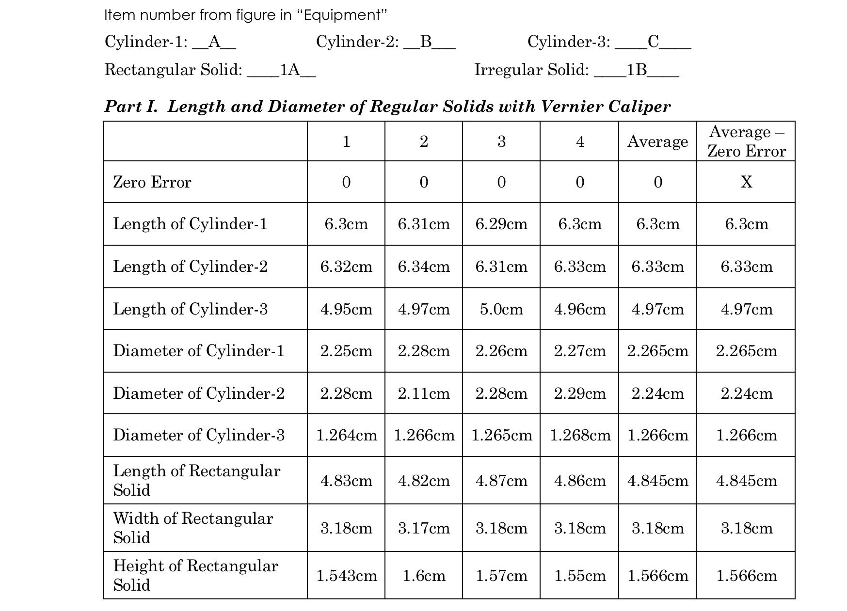
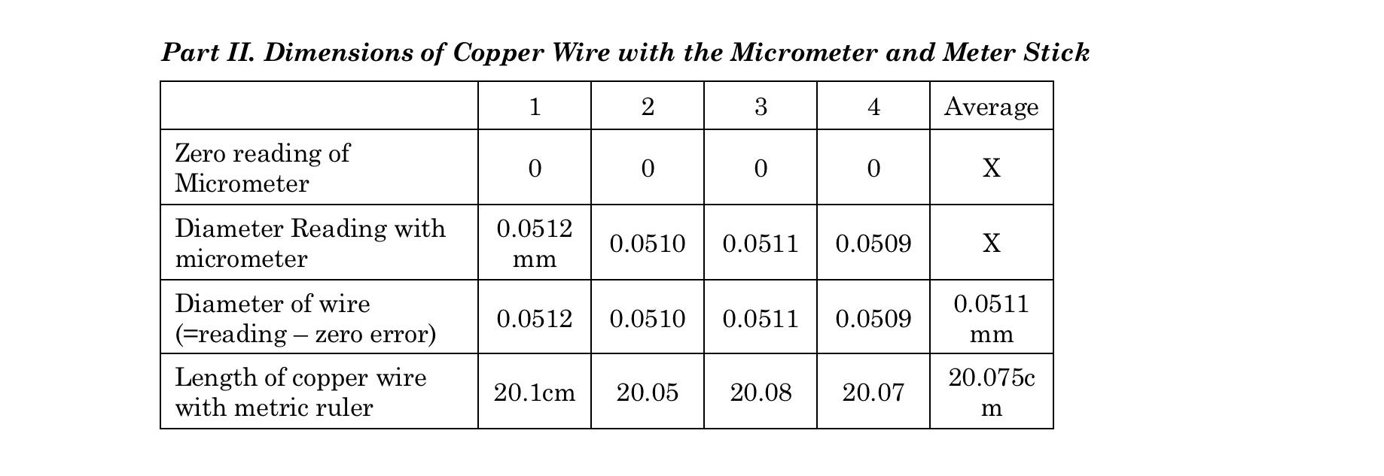

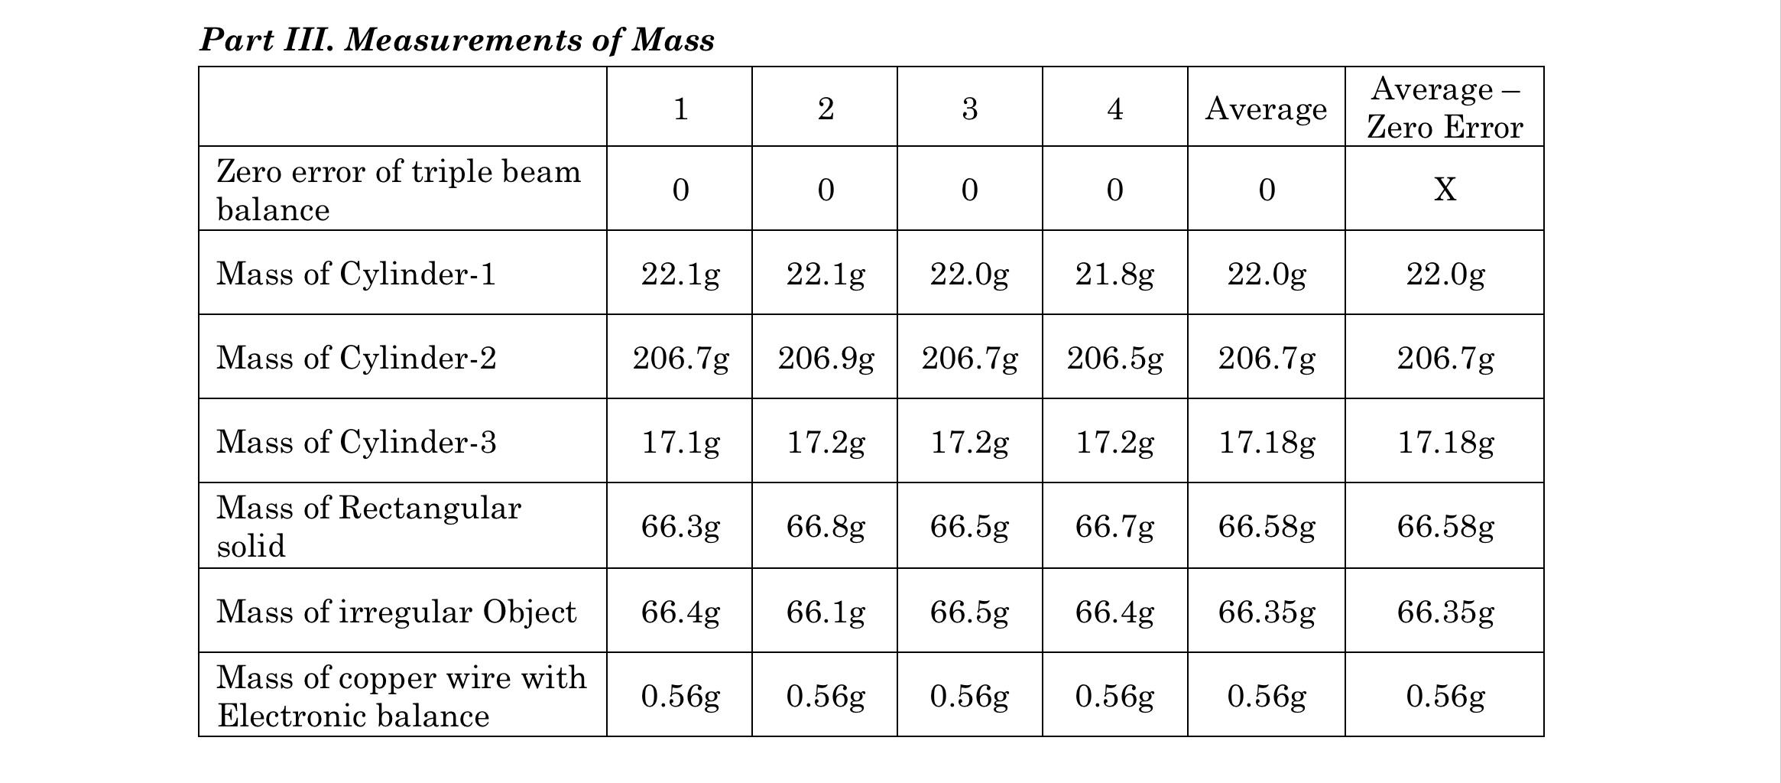
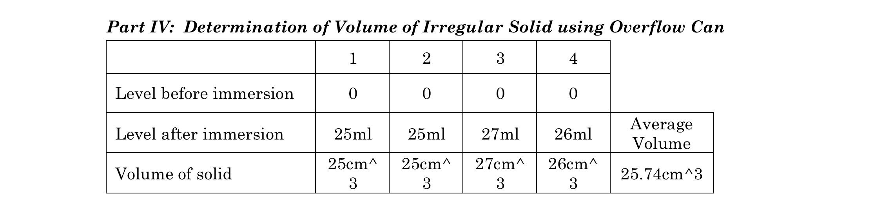

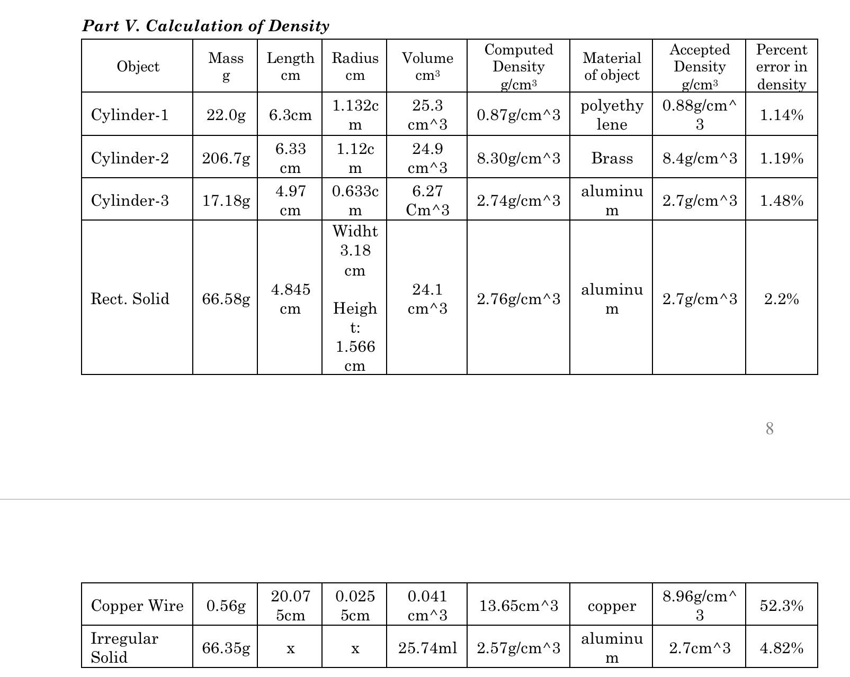

CALCULATIONS:
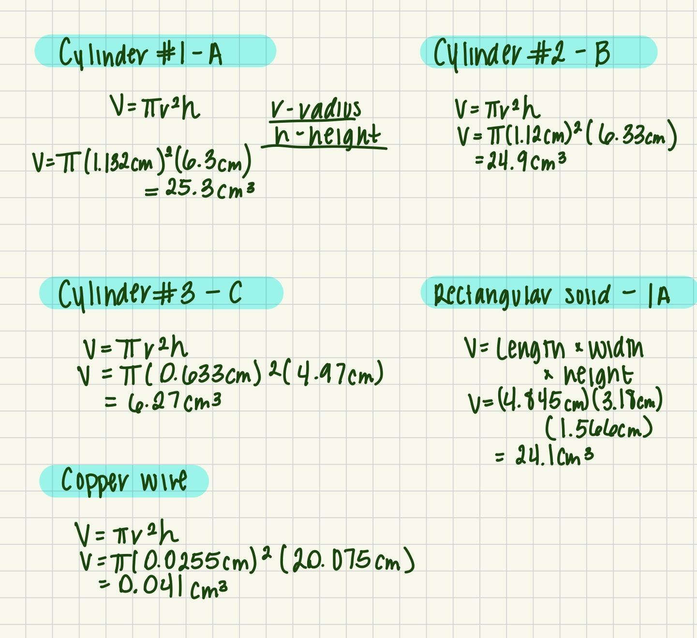

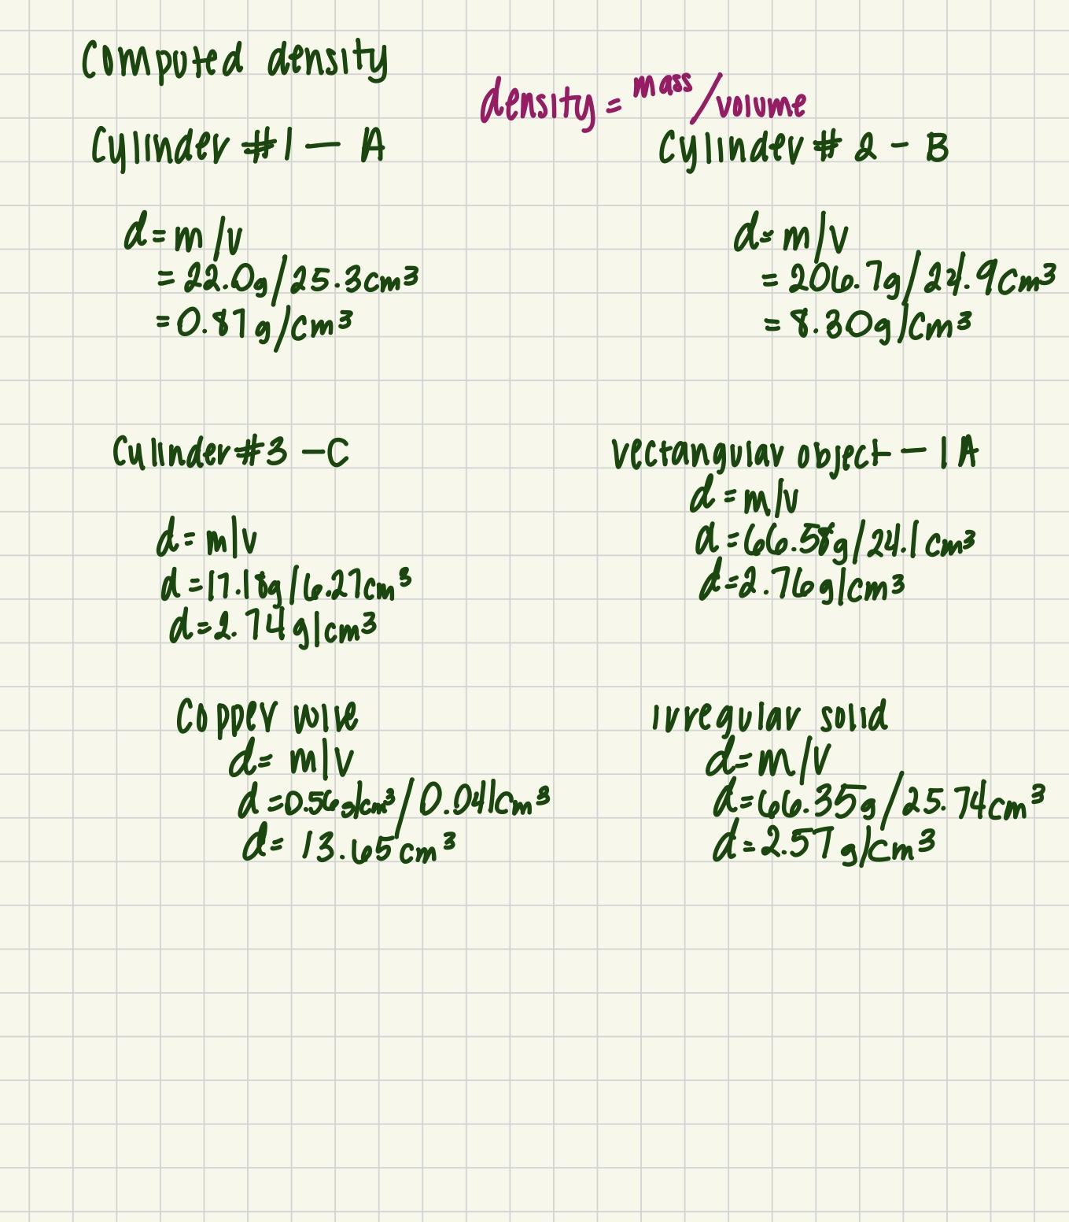
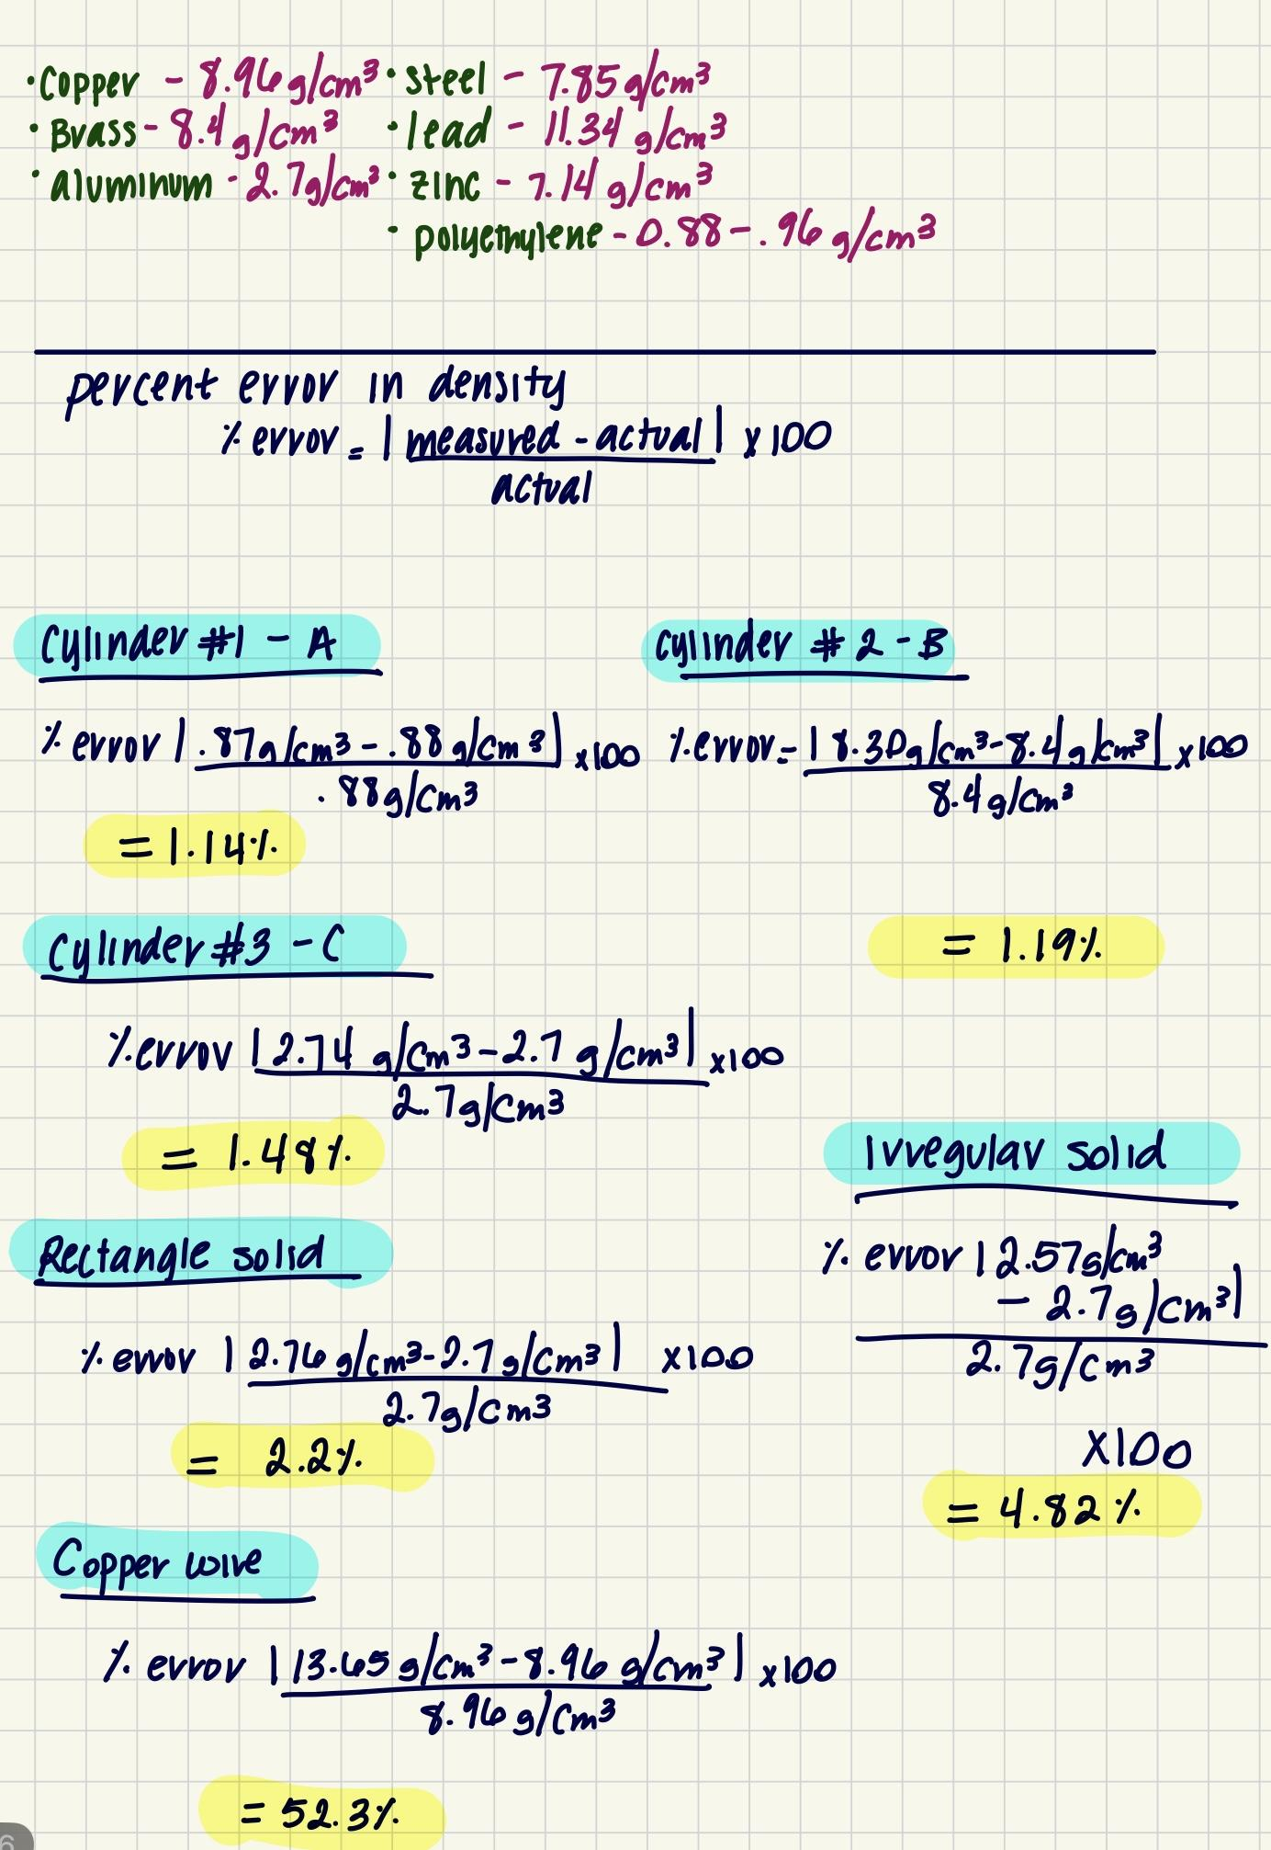

RESULTS:
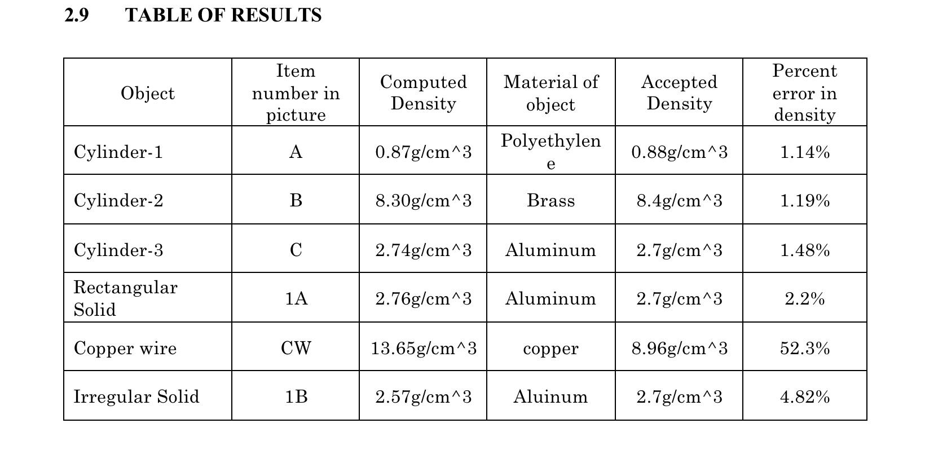

SOURCES OF ERROR:
- Measuring of the copper wire
- The copper wire has minor bends, which cannot be effectively flattened into a straight line. These minor bends cause minor imperfections when measuring its length.
- Measuring of the object dimensions
- The vernier caliper was required to measure some of the larger objects due to the limited size of the micrometer. The caliper can be over-torqued depending where the object was measured on the caliper’s clamp.
- Calibration
- Some of the equipment must be calibrated before usage. This requirement being done in-lab, as well as it needing to be done by eye, can result in calibration errors that would impact the lab data.

DISCUSSION:
Initially, it was expected that the measurements of the objects using the equipment provided would be the same each time. The results showed that depending on where on the equipment the object was placed, where on the object the equipment was placed, the strength of the team member, etc, would result in slight imprecisions in the recorded data.
The results gathered for the densities of various objects were calculated based on the measured mass and volume of each object, and then using the formula for density to calculate. This was then noted down and using that, the material of the object was determined, and then the calculated density was compared to the accepted density. Looking at the results gathered, these results back up the hypothesis stated since using the measured mass and volume gave us the density of the object with little to no percent error. The majority of the results make sense, with only a 1-4% error, except for the copper wire, which had a 52% error. The cause of the large percent error was most likely due to the copper wire having many bends and kinks in it, leading to an inaccurate reading. This can be solved by using wire straightening pliers or any form of pliers that can effectively straighten out a copper wire.
Another anomaly in the data is the irregular solid density, which has a 4% error. The error was most likely caused by measuring errors, such as the amount of torque on the vernier caliper or where the object was placed on the caliper’s vice. Looking at the calculated densities of the objects, and the accepted densities of the objects, the calculated results are mostly within a 5% error, with the majority of them only having a 1% error. What likely caused these small errors is the measuring equipment, in which any faulty calibration of the equipment would throw off the data.

CONCLUSIONS:
In conclusion, the experiment successfully demonstrated the principles of density by use of vernier calipers, micrometers, and water displacement. By determining the volume of the objects and the mass of the objects through measurement, the density of each object can be calculated. The measurements taken during the procedure allowed for a deeper understanding of how volume can be calculated with formulas or measured by mechanical means.

